Homeownership Application

Please submit applications to:

Dakota County Community Development Agency
Attn: Karly Schoeman
1228 Town Centre Drive
Eagan, MN 55123

Be sure to clearly label all attachments.

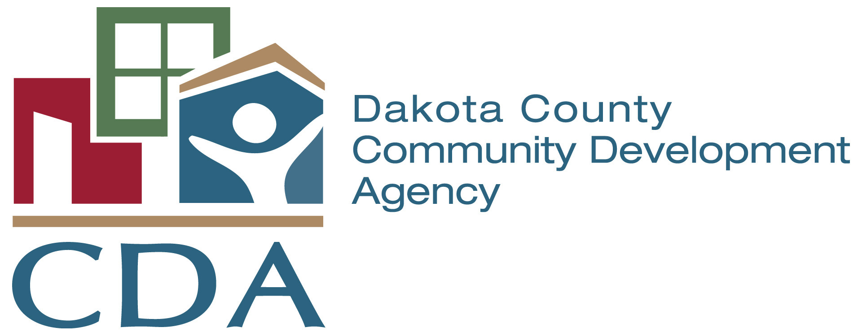

APPLICANT INFORMATION

Applicant Name:
Contact Name:
Applicant Address:
City: |  | State: |  | Zip:
Phone: | Fax: |  | E-mail:
Developer Name, if applicable:
Development Name:
Development Address:
Amount of HOPE funds Requested:
Proposed Matching Funds (2:1 Match Required):

Type of Activity: Entry Cost Assistance for Homebuyers
New Construction of Homeownership Units
Rehab of Owner Occupied Units

- Describe the housing proposal in detail.

- Describe the applicant’s experience with projects similar to the proposed project.

- What is the target population for the proposal?

- Describe the need for a HOPE loan to complete the proposed project. List other funding sources that have been or will be applied for that may impact the need for HOPE funding:

- Describe the process for ensuring the homeowners meet the income eligibility for HOPE funds (80% of Area Median Income) and the applicant’s experience with the income verification process.

- Describe the process to market the proposed project.

- Describe any homebuyer education or counseling services that will be required and how these services will be provided.

- Mark the objective(s) the proposed development will meet and describe the ways it will meet these objective(s):

Increase access to decent, safe and affordable housing for low/moderate income households
Improve the condition of existing rental housing stock for low/moderate income households
Support community redevelopment and revitalization efforts that improve commercial and
neighborhood areas

- For new construction or rehab proposals, describe and provide contact information for the applicable members of the development team, including the project manager, developer, architect, engineer, and general contractor. If a member of the development team has not yet been selected, note the timeframe and process for selection.

- For new construction or substantial rehab proposals, submit plans or a detailed scope of work as Attachment A. If plans are not yet available, describe the timeframe for availability. For moderate rehab proposals, describe the typical rehab activities undertaken and submit written rehab standards if applicable as Attachment A.

- For new construction or rehab proposals, describe any green building techniques or energy efficiency measures being proposed.

- For new construction and substantial rehab, submit a proposed construction schedule as Attachment B.

- For new construction and substantial rehab, submit a detailed development budget, including hard costs, soft costs, proposed developer fee, financing costs, proposed reserves, and proposed sources and uses as Attachment C.

CERTIFICATION

I certify that the information contained in this application and its attachments is true and correct and that it contains no misrepresentations, falsifications, intentional omissions, or concealment of material facts. I also understand that any funding awarded will be in the
form of a loan.

Signature of Authorized Official Date

Name of Authorized Official

Title


Information &
Application Instructions

The Dakota County Housing Opportunities Enhancement Program is designed to provide resources to create or preserve affordable housing throughout Dakota County. Funds are to be used as a source of gap financing that can in turn be used to leverage public and private sector funds for the expansion, preservation, or rehabilitation of affordable housing units. The funds can be used with new construction, housing rehabilitation, and indirect or direct assistance for homeownership opportunities.

In order to be considered for funding, applications must meet the following threshold eligibility requirements:

- Income Requirements. Homeownership projects must serve persons at or below 80% of the county’s median income.

- Purchase Price Requirements. In general the overall purchase price must not exceed the current First Time Homebuyer purchase price limit used in the Dakota County First Time Homebuyer Program. In addition, individual homeownership affordability will be based on standard lending ratios used by FHA, Fannie Mae and Freddie Mac for community lending programs.

- Design Requirements. The CDA must approve the architectural plans for new construction or substantial rehab proposals. The threshold for substantial rehab will be evaluated based on the scope and complexity of the proposal. All applicable codes, rules and regulations including but not limited to zoning, building and energy codes, accessibility and other local, state, and federal requirements. Those developments in cities and municipalities, which have not adopted the State Building Codes, must design and construct the development to comply with the State Building Code.

- Organizational Capacity. Applications must be received from a duly created and validly existing corporation, partnership, or other entity. Applicants must also demonstrate that the skills and experience of the development team and the project management team are appropriate to the size and complexity of the project.

- Community Review. For new construction and substantial rehab proposals, at the time an application is submitted for HOPE funding the applicant must include a letter/documentation from the city in which the development is located stating the current zoning and approval status. In addition, the CDA will submit the application to the city for review and comment.

- Site Control. For new construction and substantial rehab proposals, applicants must provide, at the time the application is submitted, evidence of single owner site control or evidence that the process is in place to imminently obtain site control. Evidence includes: deed of trust, current and executed purchase agreement or sale agreement, current title showing applicant as owner, or option agreement.

- Relocation Plan. If applicable, applicants must show that a relocation plan has been developed to ensure that comparable units within the community are available and the budget is adequate to cover relocation costs.

- Leverage. Applications must be able to demonstrate a minimum of 2:1 leverage, with an exception for supportive housing developments and rehab proposals. These projects may be allowed a 1:1 leverage based on the availability of funding and a CDA underwriting review.

- Demonstration of Need. Applications must be able to support the need for HOPE funding to complete the proposed project. CDA staff will conduct an underwriting review and analysis of proposals to confirm the need for HOPE funding.

- Project Feasibility. The applicant must demonstrate project feasibility based on current housing finance conditions and the ability to complete the project in a reasonable timeframe. CDA staff will review proposals for project feasibility and continue to monitor project feasibility on an ongoing basis.

Funding will be awarded on an open pipeline basis until all funding is exhausted. The maximum available to projects serving the target population may not exceed $30,000 per unit or a maximum of $750,000 per development. Funding awarded from the HOPE Program will be in the form of a repayable loan. Terms of the loan will be based on the length of affordability.

The award of HOPE funding is based on the information provided in the application. The CDA retains the right to reject in whole or in part any application for any reason. If you need clarification on the application, please contact Karly Schoeman, Housing Finance Program Coordinator, at 651-675-4488.

Submit applications to: Dakota County Community Development Agency
Attn: Karly Schoeman
1228 Town Centre Drive
Eagan, MN 55123

Please make sure all attachments are clearly labeled.

